RIBA UK Awards Form Sustainability Guide 2024

The RIBA 2030 Climate Challenge sets a series of targets for practices to adopt to reduce operational energy consumption, embodied carbon emissions and potable water use. Each year, the RIBA Awards eligibility become more closely aligned with the objectives of this challenge, demonstrating the crucial role architecture must play in mitigating and adapting to the climate crisis.

Some information requested is mandatory dependent on project size, or to be considered for the RIBA Reinvention Award. Please complete as many questions as possible and as applicable to your project so that the RIBA jurors can best understand the credentials of your scheme. Please note you will need to provide a breakdown of the project’s whole-life carbon credentials to be considered for the RIBA Stirling Prize 2024.

Please note: If mandatory data is required but not applicable to your project, please insert ‘0’ (zero) in the data field and provide an explanation in the relevant text box - e.g. a bridge will not be able to provide some mandatory data due to its typology.

Gross internal conditioned floor area (m²)
'Gross Internal Conditioned Floor Area' is the Gross Internal Floor Area that is conditioned (e.g. heated and/or cooled).

% Occupancy during 12-month period
The percentage occupancy, for this form, should relate to the energy data collection period.

Airtightness (m³/hr m² at 50Pa)
Mandatory for projects over 1000m²

Provide any other supporting information relating to the building specification. (optional)
max. 200 words
Please include sustainability certifications achieved.

Outline the drivers, concepts, and performance of the building in terms of sustainability.
max. 300 words
Has sustainability been a key driver of the architectural concept, building form, construction, systems, and building use? Describe any performance analysis undertaken and the measured sustainability outcomes. Were there any special project objectives, challenges, or constraints? Was the design reviewed against the impacts of future climate change (e.g. future weather, flood risk, overheating risk)? Are there any innovations in sustainable construction? What are the key indoor and outdoor water use reduction strategies? Please state how the project aligns with the RIBA 2030 Climate Challenge.
Predicted energy use (kWh/m²/y)
This is the total annual predicted regulated and unregulated energy use (measured in kilowatt-hours per metre squared per year based on the gross internal area (GIA) of the building).

Actual energy use (kWh/m²/y)
This is the total annual gross operational energy use (measured in kilowatt-hours per metre squared per year based on the gross internal area (GIA) of the building) taken from measured data. Figures should reflect gross energy use and therefore should include energy used on-site from any on-site renewables. The measurement should be taken from energy meter readings (or energy bills + PV meter) for the building over a year, so that both winter and summer seasons feature in the calculation.

Is gas used on site?
□ Yes
□ No

Gas usage (kWh/m²/yr)
This is the actual annual gas usage.
If no gas is used on-site, please insert ‘0’ (zero).

On-site renewable energy generation (kWh/yr)
Actual annual on-site renewable energy generation does not include heat pumps.

Potable water use (litres per person per day)

Is your project connected to a district heat system?
□ Yes
□ No

Please provide details. (optional)
max. 200 words
What is the Primary heating technology (e.g. gas boiler, gas combined heating and power, air/water/ground source heat pump)? If combined, please give an approximate split. At what temperature is the network delivering the heat? Is the heat upgraded in the building?

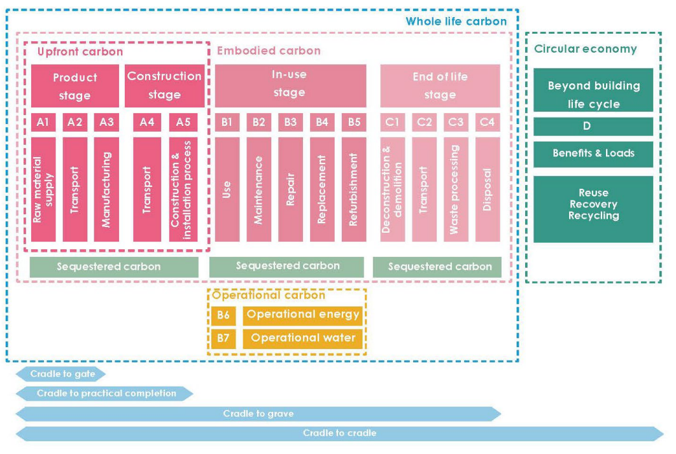
Life cycle stages defined by BS EN 15978:2011
Credit: LETI, RIBA, WLCN

Describe any strategies used in the building’s design to reduce embodied carbon.
max. 300 words

Building design life (years)

Whole-life carbon (KgCO₂eq/m²) (optional)
This typically includes RICS modules A1-A5, B1-B7, & C1-C4.
This question is marked as optional for entrants, but is mandatory in order to be considered for the RIBA Stirling Prize 2024.

Embodied carbon (KgCO₂eq/m²) (optional)
This is the embodied carbon figure for the whole building, typically RICS modules A1-A5, B1-B5 & C1-C4. This question is marked as optional for entrants, but is mandatory in order to be considered for the RIBA Stirling Prize 2024.

Upfront carbon (KgCO₂eq/m²) (optional)
This is the upfront carbon figure for the whole building, typically RICS modules A1-A5.
This question is marked as optional for entrants, but is mandatory in order to be considered for the RIBA Reinvention Award, RIBA National Awards and RIBA Stirling Prize 2024.

Confirm the basis for the carbon footprint breakdown provided above. Please expand and explain the method used for the calculation. (optional)
max. 300 words
Confirm which RIBA Stage calculations were undertaken at, and state assumed building life and assessment boundary (cradle to gate/cradle to practical completion/cradle to grave). Confirm whether RICS or PHPP Ribbon whole-life carbon methodology was used, and which life-cycle stages were included (i.e. Upfront carbon RICS Modules A1-A5; or Embodied Carbon RICS Modules A1-A5,B1-B5,C1-C4; Whole Life Carbon RICS Modules A1-A5,B1-B7,C1-C4).
If you have been unable to provide whole-building carbon figures, but have calculations for specific building elements, you can use this textbox to provide the data and specify how they have been reached.

Explain key ecological strategies. (optional)
max. 300 words
Does the scheme significantly enhance biodiversity, increase green infrastructure or create opportunities for productive growing spaces (e.g. local food production)? Were considerations made for biophilic design? Does the scheme entail removal of Category A and B trees and what measures have been taken to mitigate for any loss? Does the scheme avoid building on designated landscapes (e.g. greenfield land, Areas of Outstanding Natural Beauty, locally designated landscapes)? If not, what measures have been taken to mitigate the impact on the environment? Does the scheme create, restore or include provision to protect and enhance habitats? If yes, how is this safeguarded for future years? Please refer to the RIBA Sustainable Outcomes guide for further information.

Biodiversity net gain (BNG) % (optional)

Any other supporting information relating to the Sustainability data. (optional)
max. 200 words

